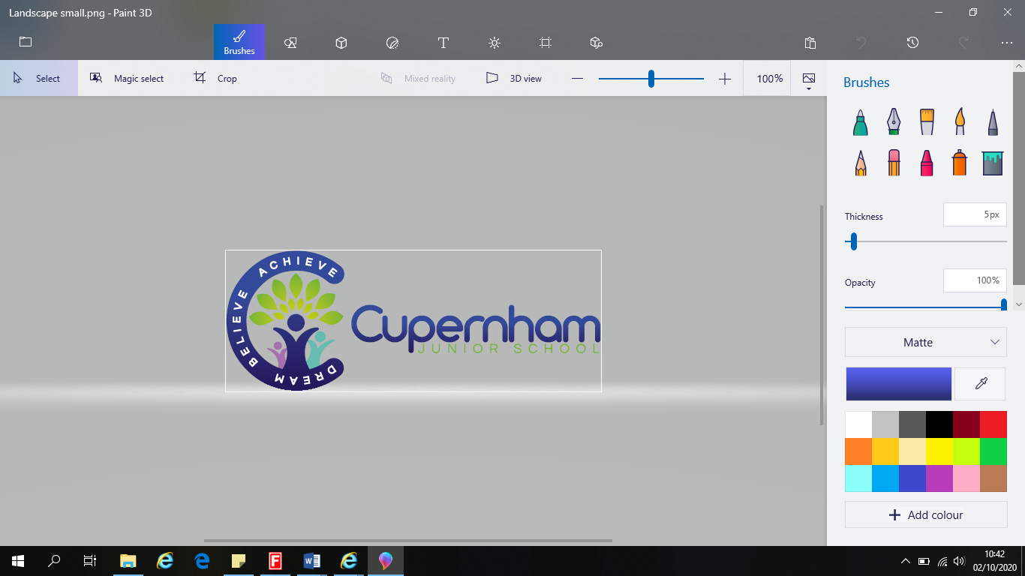 |  | Cupernham Junior School History progression 2023 - 2025  Retrieval - Remember when?
Year Group | Year 3 |  |  | Year 4 |  | Year 5 |  |  | Year 6
Terms | Spring 1 |  | Summer 1 | Spring 1 | Summer 1 | Autumn 2 | Spring 2 | Summer 2 | Autumn 2 | Summer 1
Topic  Substantive knowledge | Digging up the past!  Lindow man  How did homelife change between the Neolithic, Bronze and Iron Ages? |  | Roman Remains  How much power did the Romans have over the people of Britain? | Saxons and Scots  Why did the Saxons and Scots fight over land? | “Viking Warrior or Saxon King?  Who had more power the King or the warrior? | “A civilized Bunch”  What are the similarities and differences between the civilizations | “Tomb Raiders”  What was the biggest influence on Egyptian daily life-the spiritual or the natural? | “Eureka”  What Greek legacy has had the most impact on life today? | “The Road to Baghdad”  Was the early Islamic civilization a beacon of light in the dark ages? | “The Spitfire Coast”  Local history study  WW2  What impact did Hiitler’s decision have on the South Coast of England?
Substantive themes  Power – monarchy; empire + government and society, territory  People – settlements; invasion + Culture and beliefs  Progress – education, tools; trade and technology | People  Settlements/  changes to homelife  Progress  tools |  | Power  Empire  Emperor  territory  People  culture  beliefs | People  Settlement  Culture  Beliefs  Power  territory | People  settlements; invasion + Culture and beliefs  Power  territory government and society, | People  Settlements, culture, beliefs | Power  Society  people  Culture + beliefs | Power  Empire, government  Progress  education, tools; trade and technology | Progress  education, tools; trade and technology | Power  Territory  People  invasion +belief  Progress  education, tools; trade and technology
Disciplinary Knowledge
Chronology including duration/ interval/ overlap  Understands that past civilisations overlap with others in different parts of  the world, and that their respective times. Uses more precise chronological vocabulary | Timeline comparison of duration |  | Examine expansion of empire via timelines and world map | Timeline and consider where they are from and why they may have left their homeland.  Explore where and when Vikings came from | Timeline and overlap of duration | Compare durations and identity overlap. Compare location on the world map. |  | Explore duration on timeline | On timeline compare Iraq timeline “Beacon of Light” with British timeline and events happening in Britain’s “Dark Ages” | Timeline of the key events - internationally/ nationally and locally
Characteristic features of the period/ society studied  Describe and explain main features associated with the period/civilisation studied, mostly using period specific language | Tools, technology, burial, shelters and settlements, art. |  | Romanisation of Britain | Change from Paganism to Christianity/Saxon culture  What was Viking Britain like? | Under different monarchs, how did Britain look characteristic features and how these differ depending on the ruler | Explore civilisations – similarities and differences |  | Looking at similarities and differences between Athens and Sparta | Use sources to determine the characteristics features of the life and culture of people living in Baghdad | Use sources to identify what life was like before during and after WW2 in Britain and in the local area.
Change & continuity  Describe and give some examples of a range of changes in history over a period of time and identify some things which stayed the same. | Between different periods – tools, burials. |  | Romanisation – what changed and what continued? | Changing Saxon kingdoms, Christian conversion from paganism  What stayed the same and what changed under Viking rule? | Similarities and differences throughout reign |  |  |  |  | How did life change during WW2 and as a result afterwards?
Cause & Consequence inc short term/ long term  Explain consequences in terms of immediate and longer-term effects and/or that people were affected differently. Link causes or explain that one cause might be linked to another making an event much more likely to happen. |  |  | Why did the Romans come to Britain? What was the main impact?  Short term impacts? | Why they came to Britain. Why/How they converted to Christianity?  Why did Vikings come to Britain? Consider conflict with Anglo Saxons | Decisions made by monarchs and how this impacted on people of the period |  |  |  |  | Short term effects of the war – particular focus on the people within the local area – army/navy
 |  |  |  |  |  | - most significant legacy
Significance Inc short term/long term |  |  | What is the most widespread and enduring aspect of their legacy? | Saxon Legacy-language/learning  Alfred the Great - Winchester | Exploration of impact? | Compare achievements of civilisations |  | Most important legacy | Consider the significance of the building sin Baghdad and the settlement built up around the Mosque. | As a turning point - impact of WW2 on political and economic and society
Interpretation of the past inc how and why contrasting views arise  Recognise differences between versions of the same event and can give an explanation of why we might have more than  one version. Understands that historical  understanding is continuously being revised; if we find  new evidence we have to re-write the past. | Realise that scarcity of information means gaps have to be filled with reasoned expectations |  |  | Does Alfred deserve the title “Great “or was he just lucky?  Describe how different  Interpretations arise. Understands that historical  Where they raiders or traders? Consider evidence | Considering evidence from range of sources | . |  | Understand that different accounts of the past emerge for various reasons – different people might give a different emphasis – Battle of Troy? | Misinterpretations of the Islamic faith | Was the war the same experience for everyone?  How was the local area impacted?
Historical Enquiry  Inc source comparison and analysis  Describe and question the origins and purposes of  sources using knowledge of periods and civilisations  Asks perceptive questions |  |  | Deducing information from a variety of sources | Source comparison | Considering evidence from a range of sources to raise and answer questions | Examining achievements and understand some interpretations are more reliable than others |  | Which of the achievements from Ancient Greece have an impact today? | Children consider impact and relevance of the Ancient Islamic civilisation on the rest of the world. | Artefacts and sources analysed in order to justify opinions
 |  |  | - legacy |  |  | - legacy |  | - legacy
Organisation and Communication | Recognises that the absence of certain types of sources can make it more difficult to draw  conclusions. |  |  | Know to find, select and utilise suitable information and sources to formulate and investigate hypothesis. |  | Construct simple reasoned arguments about aspects of events, periods and Civilisations studied. |  |  | Question source reliability with reference to the period or civilisation and/or the provenance of a source, considering why different sources may give conflicting information and offering reasons for this.
NB you will not necessarily have entries in every box for every topic. Not all skills will be covered in all topics. However, each skill/process should be visited at least twice in a key stage and approached at a higher level in the later visit. KEY:  light use of skill,  overt practice of skill  strong emphasis on skill

Prior learning – KS1
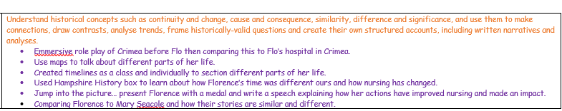
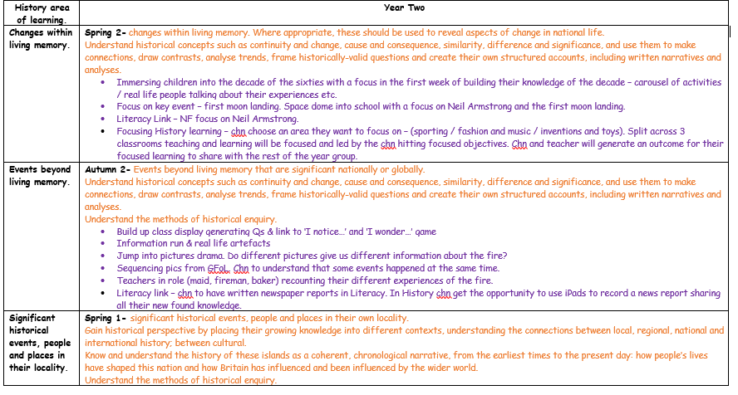

Mountbatten School KS3

In Year 7 students explore interpretations of medieval kings and assess the extent of their power. This then links to their studies of the Tudors and issues of control that this famous dynasty had to resolve, before tracing the origins of the English Civil War.

In Year 8 we move onto the grime, sewage and slime of the Industrial Revolution. Students learn about the African kingdom of Benin and the impact of the British Empire and the trans-Atlantic slave trade. We continue our studies by looking at the significance of the American and French Revolutions before evaluating the huge changes which take place in the 20th century brought about by the Suffragettes and the First World War.

